2701ICT Interactive App Development

Assignment 1 – App Design and Prototype

Jacob Murphy

Student Number: S5259481

Email: [Jacob.murphy@griffithuni.edu.au](mailto:Jacob.murphy@griffithuni.edu.au)

Associate Professor Kaile Su

Contents

Project Overview 2

Target Audience 2

App Features 3

Functional Requirements 3

Storyboard 4

Screen Flow 7

Wireframe / Basic Prototype 8

# Project Overview

### Target Audience

We have been contacted to create an app that allows users to plan a trip to a custom destination and add events, activities, and images of their trip. The target audience of the TravelNexus app is young people who are excited to travel but encounter issues planning, organizing, and sharing their trip ideas. Websites that help people plan their trip are rather confusing, and there an overwhelming number of options for flights accommodation and events. Many users want the ability to list their activities and notes about what they want to do while on their holiday, in an easy to access and understand app, giving the user more freedom to plan how they want. Young people prefer to keep their information about anything that they are planning all in one spot, so they don’t loose it and are easily able to keep track of the information. A key feature of this app allows the users to keep their plans for the trip in one easy to reach place sorted under the destination they are planning to visit.

### App Features

The basic features required in the app to allow it to be successful, include an easy to read and understand list that would display the trip the user has created. A detailed list of activities the user wants to do for each trip/destination found when the user clicks on the destination/trip. The user will also be able to upload images that they have of the destination or places they want to visit at the specific destination they have added. A map will also be implemented to allow the user to easily see where they have travelled in the past or where they want to travel in the future.   
On the user account tab, the user will be able to edit their first name, last name, email address and password. A graph will also be displayed showing the user which trips they have planned along with the number of events that each trip has. It will be in the form of a bar graph, bubble chart or a plot.

# Functional Requirements

The function requirements for the app design are:

Login Screen:

* Username/First name input (for the prototype, this screen will use an array of users, where the first name will be used as the username)
* Password input (password found in the same array)
* Create new account (this feature will be fully applied in Assignment 2)

Create Account Screen:

* First name, Last name input
* Email input
* Password and password confirm inputs

Home Screen:

* Display list of destinations
* Tabs to navigate to other pages
* Swipe menu on list items (edit, remove, add trip details)
* Clickable list objects (allows user to view details (number of days, trip type, activities)
* Button to display destination creation form

Destination Creation Form:

* Location of the destination
* Description of trip/destination
* Date travelling
* Image for the trip (optional)

Edit trip Form:

* Displays name, description, and date (can all be edited)
* Save button

Trip Details Page:

* Displays list of events/activities
* Accommodation types
* Number of people
* Locations
* Add images

Map Page:

* Displays a pin of the destination of user trips
* User can swipe globally to find destinations

Account Page:

* Change First name, Last Name, email, password
* View how many trips have been created in each country

# Storyboard

The story board displays how the user will interact with the app.  
The user starts at the login page, where they can either create an account or login with the existing account. They then view the list of destinations, to start with there will be no destinations displayed. The user can then create a destination with the ‘New Destination’ button which will bring up a modal where they can enter the destination name, travel date and a brief description of the trip.   
The user will then be brought back to the main page where they can add more details to the trip by swiping right on the destination in the list and adding a list of events or activities that they will do at the destination, add an image, and add more details about accommodation, how many people and type of trip.   
From any of the pages the user can access the other two tabs, the Map tab and Account tab. The map tab allows the user to view a map that has a pin in each of the locations they have in the list. If there is a list of 5 different destinations or trips the map will display 5 pins around the map of where the destination is.   
The account page allows the user to edit their account by changing their name, email, and password. It will also display a chart that will have bubbles that will be each location and the size of the bubble represents how many activities or events that the user has listed for each destination.   
This is displayed on the next page.

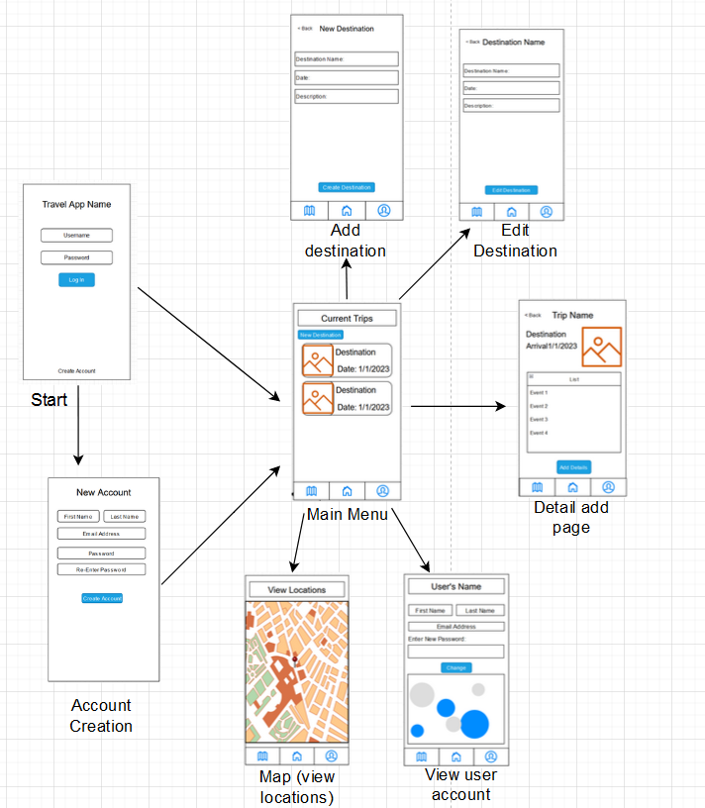

# Screen Flow

# Graphical user interface, text, application Description automatically generatedGraphical user interface, text, application Description automatically generatedWireframe / Basic Prototype

The account creation/signup page allows the user to enter their first name, last name email and password to create an account. They then can access the main page

The login page allows the user to navigate to either the account creation page (sign up button) or the main page (login button)

The main page will allow the user to create new destinations/trips. Each item in the list will be swipe able, to reveal edit, remove and add detail options.

The Add new trip page allows the user to enter some basic information that will be displayed in the list on the main page.

The add details page allows the user to enter more detailed information about the trip that they added.

The user account page is accessible from the tab menu at the bottom of the page. It allows the user to change their first name, last name email address and password. A graph will also be displayed at the bottom of the page to show the user the destination that has the highest number of activities/events planned.

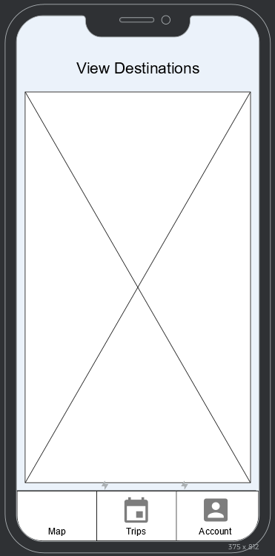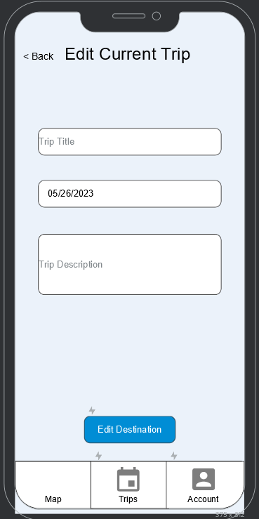

The map screen is accessible by the tabs at the bottom of the page. It will display the locations of the users’ trips that they have added, by using a pin in the map. The user will be able to scroll around on the map to find these destinations.

The edit current trip page is accessible from swiping on the destination/trip and selecting the ‘Edit’ button. It will display a modal where the user can edit the name, date and description of the trip.